Year 4 Trip to Marwell Zoo
My class is going to Marwell Zoo on __________.

We will be going on the mini bus.
We will leave school about 9:10am.
We will arrive at Marwell Zoo about 10am.

When we arrive we will go to the toilet and then have a look around the zoo for about 30 minutes.
At 10:50 we will go to the Giraffe enclosure for a talk with one of the zoo staff.

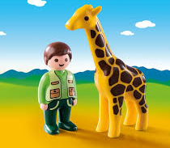
Then we will look around the zoo until lunchtime.
We will eat lunch about 12pm and play in the adventure playground for 30 minutes.

After lunch we will look around the Zoo until it is time to leave.
At 2pm we will go on the mini bus back to school.
We will be back for home time.

If I have any questions about Marwell zoo, I can ask my teachers before we go.
My teachers will tell me what I need to bring.
My teachers hope we all have a good day.

