Year 3 walk around Southsea.

Tomorrow my class are going for a walk around Southsea.
We will be leaving after register.
We will be back in the afternoon.
We will eat our lunch on the walk at a quiet place.
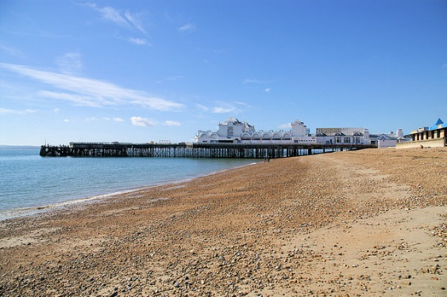
We will line up in our partners and leave the school.
We will walk down Festing Road.
We will cross the road near the Cumberland house museum.
We will then walk through the Rose Gardens.
When we come out of the Rose Garden, we will cross the road to the seafront.
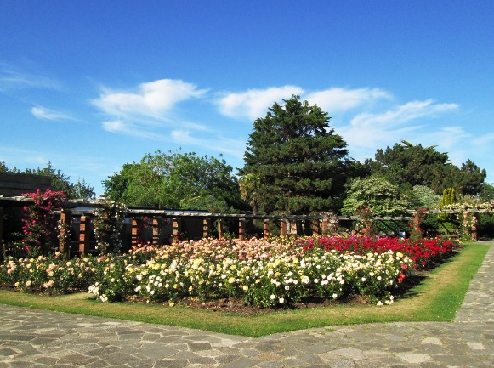
We are going on the walk as part of our Geography and Art topics.
When we get to the Seafront, we will sit down and draw in our art journals.
We will be staying on the path and looking at the beach.
When we have finished our drawings, we will line up in our partners again.
We will walk along the seafront to Canoe Lake.
We will cross the road opposite Canoe Lake.
Then we will walk next to Canoe Lake up to the road.
We will then cross the road and walk up Festing Road to school.

So that we all stay safe and have a good time there are a few rules we can follow.
- Listen to our adults at all times.
- Stay near our adults at all times.
- Walk do not run.
- Talk do not shout.
- Follow all instructions immediately.

Everyone wants us to have a good time.
Everyone wants us to stay safe.
If we follow our adults' instructions, we will stay safe.
We will have a good time.

