Greek Day in Year 4

On ____________it is Greek Day.
It will be a different day at school.
A Greek man will be teaching us about the Greeks.
There will be no maths, literacy or guided reading.
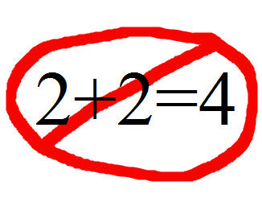
After my teacher has finished the register my class will to listen to a talk from the Greek man for about 45 minutes.
There will be different activities throughout the day including drama and a quiz.
We will move between two classrooms throughout the day.
We will still have break and lunch as normal.
My teachers would like everyone to have a fun day and enjoy themselves.
My teachers know it will be a bit noisy and everyone will be excited.
I might find this challenging.
It might be noisy for me.
It might be different for me.
This is okay. I can tell my teacher if I am finding the day challenging.
They will find a quiet place for me to go or give me another activity to do.
Everyone will be really proud of me for telling my teacher how I feel.

