Year 5 River Trips

Next week Year 5 are going on a trip to Meon River, Wickham as part of our topic work.
My class is going on _____________________.
My class teacher and TA will be on my class’s trip.
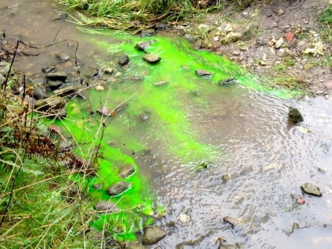
I do not have to wear school uniform on the trip.
I must bring my wellies/beach shoes in a bag.
I will need to bring spare shoes and socks.
We will leave school about 9:15 on the mini bus.
It will take about 30 minutes to get there.

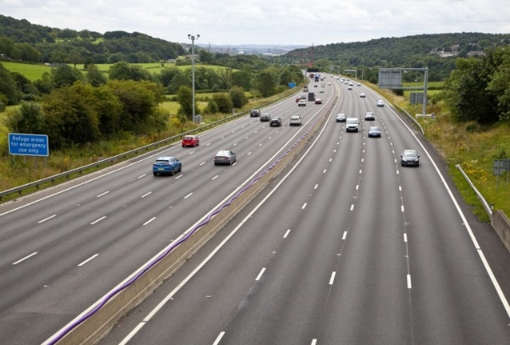

When we get there, we will park up the mini bus and take a short walk to the river.
We will listen to a talk about rivers.
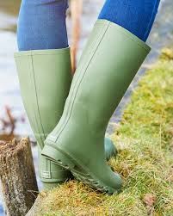
The adults will split us into 8 groups.
Adults will be helping us at different activities.
All the activities are close together so we will always be near to an adult and our class.
We will then go into the river if it is not too deep.
We will conduct tests in the river:
- Measuring the depth/width
- Measuring the speed of the water
- Dipping with nets
- Discussing our findings.

At 11:45, we will get on the mini bus to go back to school.
It will take about 30 minutes again.
When we get back we will eat our lunch.
So that we all stay safe and have a good time there are a few rules we can follow.
- Listen to our adults at all times.
- Stay near our adults at all times.
- Walk do not run.
- Talk do not shout.
- Follow all instructions immediately.

Everyone wants us to have a good time.
Everyone wants us to stay safe.

