Egyptian Day in Year 3.
On ______________it will be Egyptian Day at school.
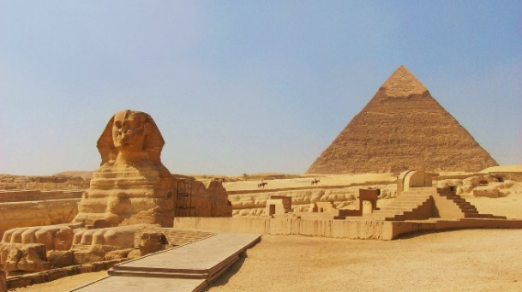
It will be a very different day at school.
Some of the children in year 3 will be dressed up.
Most of the adults in year 3 will be dressed up.
It is my choice if I dress up.
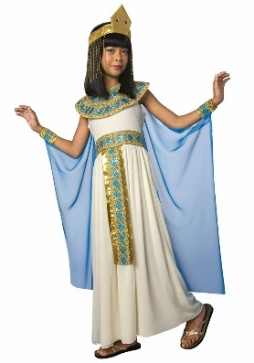
In the morning we will have our usual lessons.
After lunch it will be a different afternoon.
In each year 3 classroom there will be a different activity.
- Making hieroglyphics
- Mummification
- Making a pyramid
- Egyptian colouring and drawing.
If I chose not to take part in the activities, I can sit and read books about Ancient Egypt.
We will move around the classrooms and join in the activities.
If our parents come, we can take them round the activities.
There will be parents walking around all afternoon.
There will be an Egyptian museum in the classrooms.
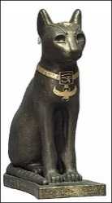
My teachers would like everyone to have a fun afternoon and enjoy themselves.
My teachers know it will be noisy and everyone will be excited.
I might find this difficult.
It might be too noisy for me.
It might be too different for me.
This is okay. I can tell my teacher if I am finding the day difficult.
They will find a quiet place for me to go and give me some books to read.
Everyone will be really proud of me for telling my teacher how I feel.

