Year 4 Trip to Fort Nelson

This week Year 4 are going to Fort Nelson.
You will be going with your class.
You will be going on the mini bus.
You are going to learn about the Romans for your topic.

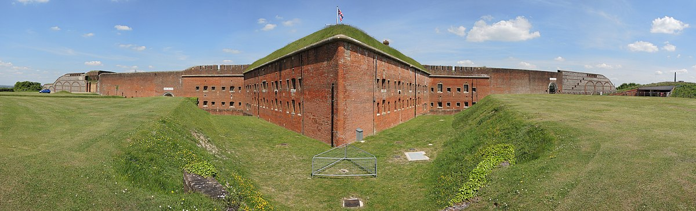

There will be adults dressed as Celts and Romans.
They will lead all the activities for you with your teachers.
You will try to follow their instructions and stay by them at all times.

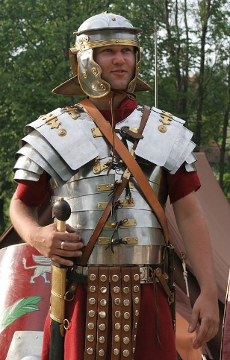

Some activities will be inside and some outside.
You will eat your lunch outside if it is warm and dry.
This is the room where you will look at Roman artefacts.

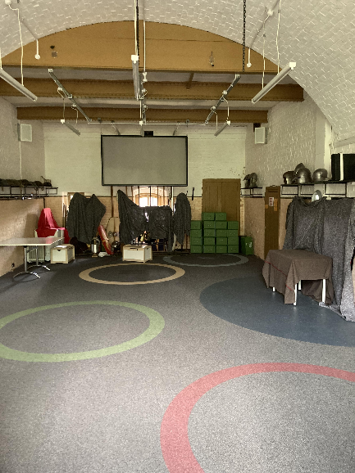

You will also learn about Celts and what they ate.
This is where you will learn about the Celts.
The room can be cold so bring a jumper or coat.

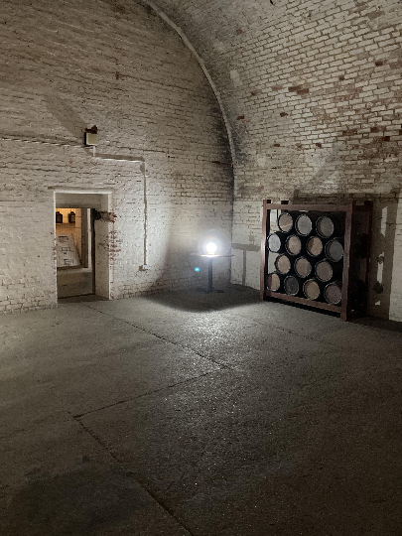

Your teachers would like you to have a fun day.
They would like you to join in.
If you are worried about any of the activities tell your teacher.
You will come back to school on the mini bus in time for home time.

