Year 5 Victorian walk

On ___________, my class is going on a walk around Southsea.
I am going to learn more for my Victorian topic.
I will look at Victorian features and other Victorian influences in Southsea.
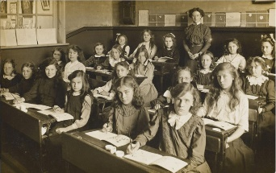
I will leave in the morning, the walk will take about 1 hour and 30 minutes.
I will walk together with my class.
My teacher will lead the trip.

So that we all stay safe and have a good time there are a few rules we can follow.
- Listen to our adults at all times.
- Stay in our walking pairs at all times.
- Walk do not run.
- Talk do not shout.
- Follow all instructions immediately.

