Year 3 trips to Spinnaker Tower

Year 3 are going on a trip to the Spinnaker Tower.
We are going as part of our topic.
My class is going tomorrow.
We will leave after register and be back for the afternoon.
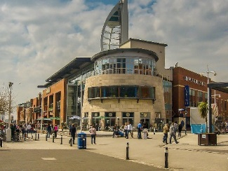
We will go on the mini bus to Gunwharf and park nearby.
We will then walk sensibly to Gunwharf.
We will count the blocks of flats we see.
We will then go up the Spinnaker tower for about 1 hour.
In the tower, we will also discuss the landscape.
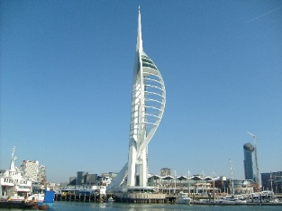
If the weather is nice, we will eat our lunch at Gunwharf.
If the weather is wet or cold we will go back to school for our lunch.
We will walk sensibly back to the mini bus.
We will then go back to school for the afternoon.
So that we all stay safe and have a good time there are a few rules we can follow.
- Listen to our adults at all times.
- Stay near our adults at all times.
- Walk not run.
- Talk not shout.
- Follow all instructions immediately.

Everyone wants us to have a good time.
Everyone wants us to stay safe.
If we have any questions, we can tell our adults before we go.
They will help us with our questions.
If we follow the rules and talk about our questions.
We will have a good time.

