Stone age fun.
In January, some of the Year 3 children are going to Hooke Court for 3 days.
There will be some changes for the 3 days.
I might be with some different children for 3 days.
I might have a different class teacher.
We will learn about the Stone Age.
We will do lots of fun activities.
- Painting Stonehenge
- Making jewellery
- Making Stone Age items from clay.
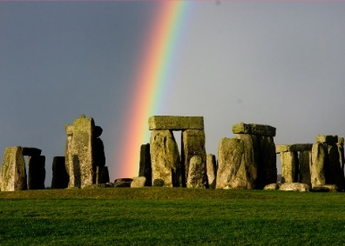
On__________, we will have a Stone Age workshop all day.
A Stone Age man will teach us about Stone Age life.
There will be games and activities to join in.
I can watch if I do not want to join in.
It will be a different week.
I might be in a different classroom.
I might be with some different children.
I might have different teachers.
I can ask the adults if I have any questions.
I can ask the adults if I need some help.
Please
Everyone wants me to have a fun week.
Everyone wants me to make new friends.
Everyone wants me to be happy.
Everyone will help me.

