Anglo-Saxon Day in Year 5
On____________, it is Anglo-Saxon Day at School.
You can choose to dress up as an Anglo-Saxon if you want to.
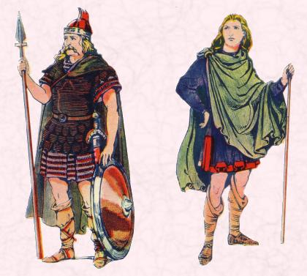
It will be a very different day at school.
There will be no maths, literacy or guided reading.
After my teacher has finished the register, all of year 5 will go to the school hall to meet the man hosting the workshop.
In 3 of year 5 classrooms there will be different activities.
A game
A quiz
Anglo Saxon names and greetings

In our classes, we will move around the classrooms and join in the activities for the rest of the morning.

After lunch, at about 1:30 we will go back to the hall.
There will be weapons to look at, a demonstration of a battle and the story of Beowulf.
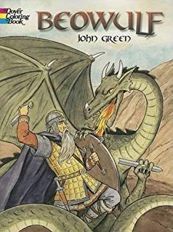
My teachers would like everyone to have a fun day and enjoy themselves.
My teachers know it will be noisy and everyone will be excited.
I might find this difficult.
It might be too noisy for me.
It might be too different for me.
This is okay. I can tell my teacher if I am finding the day difficult.
They will find a quiet place for me to go or give me another activity to do.
Everyone will be proud of me for telling my teacher how I feel.

