Winchester Science Centre and Planetarium.
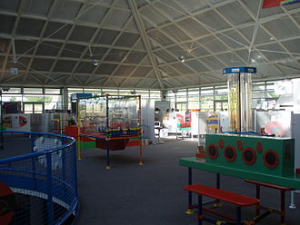
On_______, my class are going to Winchester planetarium.
I am going with them.
Everyone wants me to have a good time.
I will have a good time if I am safe and happy.
We will come to school as normal.
We will go to our classes for register.
At about 9am we will go to the mini bus.
It will take about 1 hour to get there.
On the mini-bus we need to stay safe.
We can stay safe by sitting still.
We can stay safe by keeping our seatbelt on.
We can stay safe by not disturbing the driver
When we get to the Science centre we will stay together.
I must stay near my adult at all times.
At the planetarium, I must be polite and use a number 2 voice. There will be members of the public of there too.
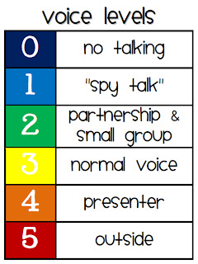
There are different activities at the planetarium:
- A space themed session.
- Lunch
- Time to explore the centre.
- A planetarium show.

After we have finished the activities, we will go back to the minibus at about 2pm and go back to school for home time.
I must remember to stay safe on the minibus.
Everyone wants me to have a good time.
Everyone wants me to be safe and happy

