Mayan Day

This week Year 6 will have a Mayan day.
It will be a different day there will be no maths, literacy or PE.
A Mayan man will come in to school and teach us about the Mayans.
He will be dressed like a Mayan. He will have a blue face.
We do not have to dress up.
We will take part in activities and watch him act how the Mayans acted.
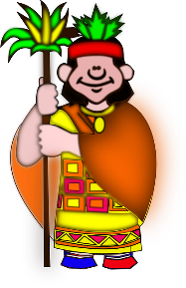
It will be a fun day.
When we are sitting and watching, he might choose children to join in if they want to.
Some of the activities will be in class and some in the hall.
If we are worried about Mayan Day we can tell an adult.
They will help me with us with our worries so that we can have a fun day.
