Mayor visit at the council chambers.

I am going with my class to visit the Lord Mayor.
We are going on ____________________.
The Lord Mayor works at the Council Chambers.
The Council Chambers are at the Portsmouth Guildhall.
We will be going on the school mini bus.

It is an interesting trip where we learn many new facts.
So that we have all have a good time, we must follow some rules;
- Walk don’t run.
- Talk don’t shout.
- Look don’t touch.
- Stay near a Craneswater adult at all times.
The Mayor is an important man and like all adults, we can show him respect.
We can do this by;
- Putting our hands up to ask him a question.
- Asking him sensible questions.
- Listen when he talks.
When we arrive at the Guildhall, a member of the Lord Mayors staff will meet us.
We will sit down with a drink and meet the mayor.
We will ask him questions and he will answer them.
He will then show us his silver collection and tell us about it.
He will also show us his office.
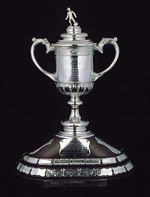
If I have any questions about the trip, I can ask an adult.
They will help me with my questions.
Everyone wants me to have a good visit to the Lord Mayors.

