Year 4 Manor Farm Trip.

The start of this week is a bit different at school.
Some of Year 4 have gone to Beaulieu.
There are some children from year 4 staying together.
We are all in class together this week.
On ____________we are all going on a trip together.
We are going to Manor Farm.
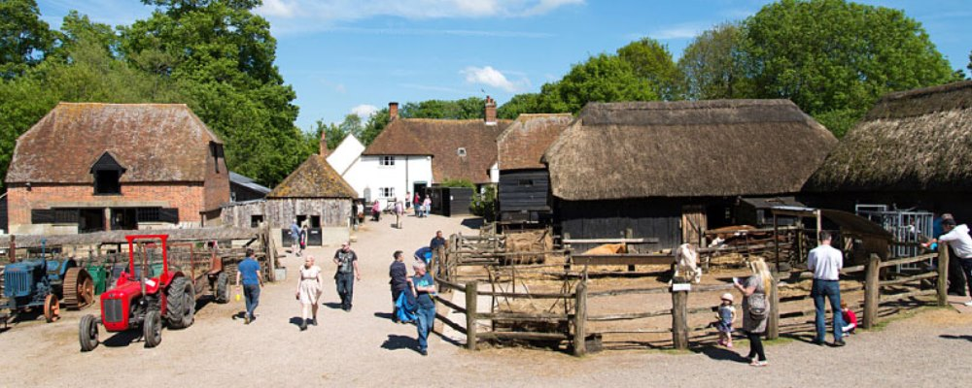
Everyone wants me to have a good time.
Everyone wants me to be happy and safe.

We will come to school at 8:40am.
We will register, go to the toilet and then get on the mini bus.
We can stay safe by sitting still on the mini bus.
We can stay safe by by keeping our seatbelt on.
We can stay safe by not disturbing the driver.
Everyone wants us all to be safe.
We will arrive at the farm about 10am.
Then we will meet in a function room.
We will have an introduction to farm safety.
It is very important to listen so I am safe at the farm.
There are different activities to do at the farm.
- Finding out where food comes from.
- Looking at the old farm machinery.
- Meeting the farm animals.
- Feeding some of the animals.
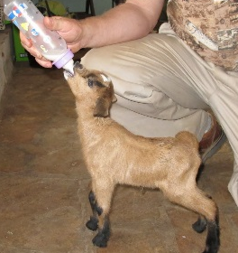
If I do not want to feed the animals, I can stand with an adult and watch.
We will do all the activities but they might change order on the day.
We will have lunch at the farm in the function room at about 12:30pm.
Everyone wants me to have a good time at the farm.
Everyone wants me to be happy and safe.
To stay happy and safe at the farm I must follow the farm rules:
- Follow instructions at all times.
- Stay near the adults.
- Tell an adult if something has made me feel confused or worried.They will help me.
- Keep my hands and feet to myself.
- Listen to safety information the staff tell me.

When we have finished all the activities, we will go back to the mini bus.
We will leave the farm about 2pm.
I can stay safe on the mini bus on the way back to school.

If I follow the farm rules I will have a good time.
I will stay happy and safe.
I will keep others safe.
Everyone will be very proud of me for following the farm rules.
We will all have a good time.

